Inside Princess Pearl’s medical bag, she had these items. Can you write a list with the name of the items. Then write a sentence with how to use two of the items.

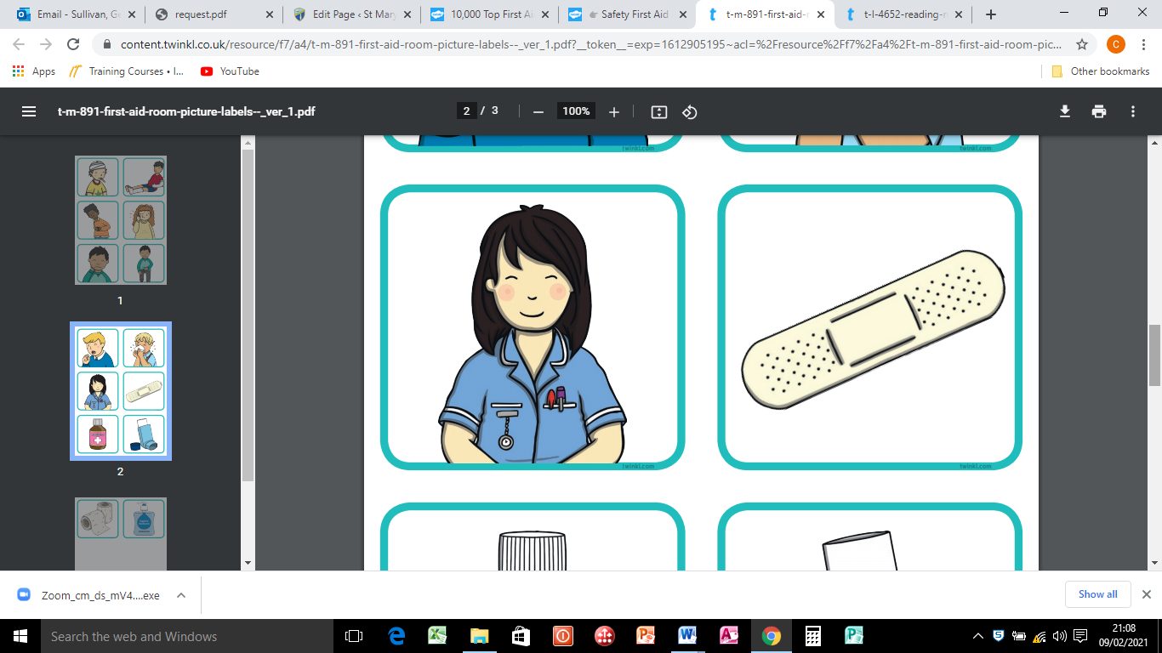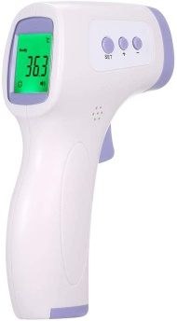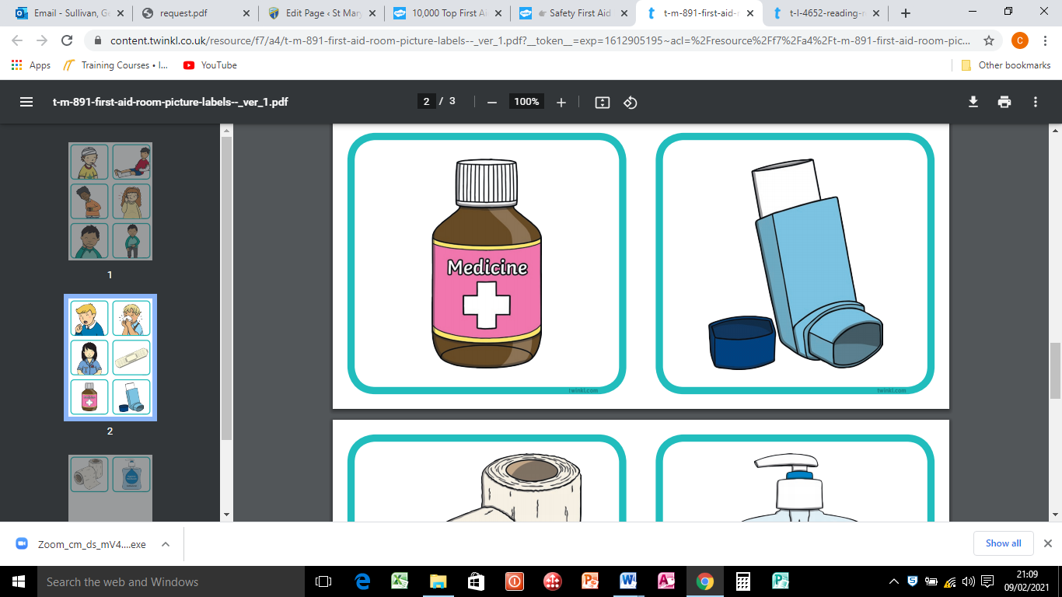

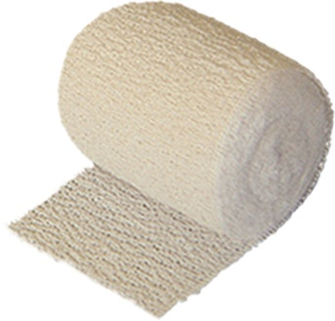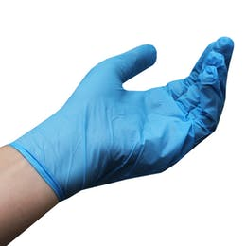

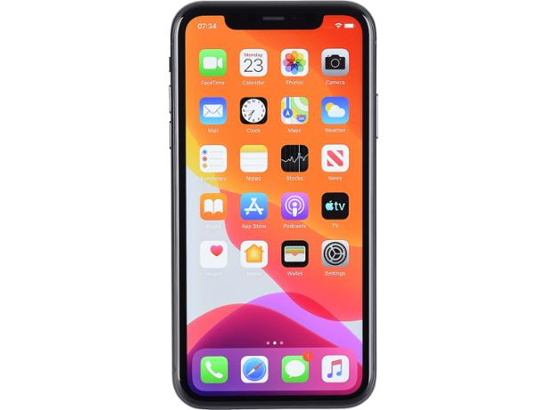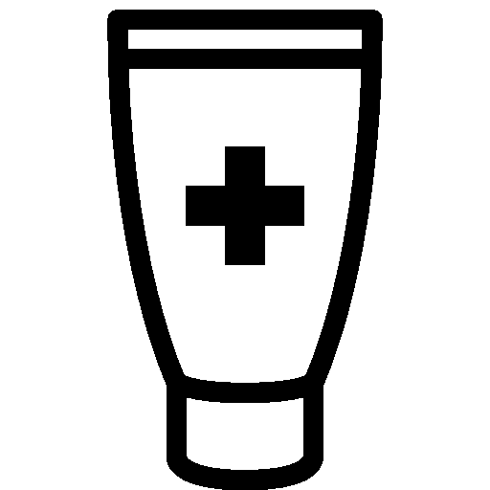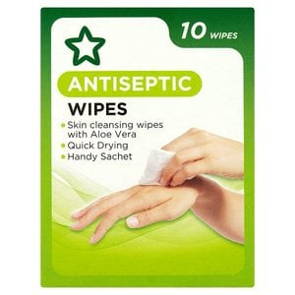

Can you think of any other items that might have been in Princess Pearl’s medical bag?

What would you do in a medical emergency?

If it was serious and you had to ring an ambulance, what number would you need to call?

Do you know your home address? If not, try and learn at least the first line.