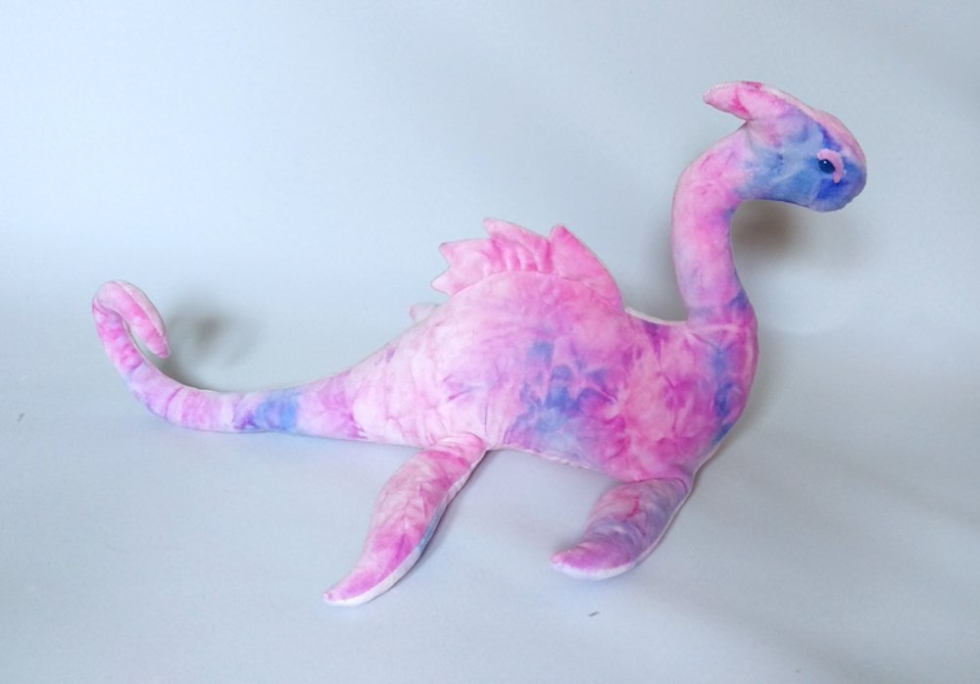

My Loch Ness Monster

|  |  |
| --- | --- |
| What do they look like?   * long, blue and pink body * curly tail * smooth scales * sharp, white teeth * small, black eyes * spiky plates on her back. * four, powerful flippers * friendly * inquisitive | How did they move?   * swims swiftly * splashes playfully * dives gracefully * roars loudly * hunts hungrily * hides secretly |