
This half-term our theme is ‘People who help us.’
Here are some activities for your child in case they have to self-isolate. As usual, if you have any queries regarding your child’s learning please email us at:
Williams@lea-st-marys.lancs.sch.uk
Jennings@lea-st-marys.lancs.sch.uk
Mrs Williams and Mrs Jennings

English  ➢Watch the video. Open the link to watch the clips about posting a letter and the job of a postman:  https://www.youtube.com/watch?v=w9jypk-wc-Y  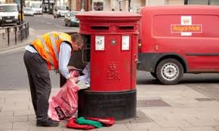  ➢Discuss What did you find interesting? Talk about what happens to a letter after you have posted it. Where does it go to? What different jobs does a postman have to do?  ➢Draw and label a picture of a postman and write some interesting words or facts you have learnt.  ➢Write Did your house receive any post today? Have a look at the address on the envelope. Does it have a stamp on? Write a letter or make a thank-you card for someone who has helped you (e.g. Grandma, Mum, Dad) and remember to use your best writing. Make sure you write their address on the envelope and put a stamp on. Take your letter and post it in a post box then see how long it takes to arrive.  ➢Research See what you can find out about the jobs of other people who help us (e.g. doctor or vet):  ➢Create a poster about a person who has helped you in the last few weeks. Draw pictures, labels and write short sentences to describe what they did. | Reading/Phonics  Practise reading and sharing a book with a grown-up every day.  Practise reading your tricky words (Wizard words).  Revise phase 2 and 3 sounds:  - Practise saying, reading and writing the sounds.  - Practise blending and segmenting simple words using games from Phonicsplay:  https://www.phonicsplay.co.uk/  Y1 - Practise reading longer words which are made up of two shorter words – e.g. ladybird, butterfly.  - Split the longer word into syllables  - Sound out each syllable  - Put them together  - Read the words. What do they say?  Y1 Challenge: Can you make your own list of longer words? (e.g. snowman, dustbin, buttercup) See how many you can find!
  RE
  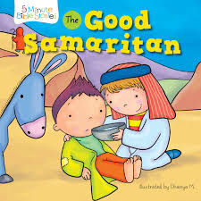Listen to the story of ‘The Good Samaritan.’ You can read it from
  the bible if you have one at home, or follow this link: https://www.bbc.co.uk/bitesize/clips/zcyr87h
  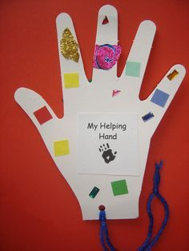Talk about the story with a grown-up. Who was kind and helpful in
  the story? Who was not so kind?
  Do you help anyone? Who have you helped?
  Make your own ‘Helping Hand’ by drawing around one of your hands
  and decorating it in any way you like. Be as creative as you can!
  Discuss with a grown-up how you can help someone this week.
Maths  Reception – Practise recognising and writing the numbers 1 to 10. Year 1 - Practise writing and ordering the numbers 1 to 20.  Try these fun, interactive maths games to help you: https://www.topmarks.co.uk/learning-to-count/helicopter-rescue  https://www.topmarks.co.uk/ordering-and-sequencing/caterpillar-ordering  Measuring length  Reception – Practise using words to compare the size of things. Follow this link: https://www.bbc.co.uk/bitesize/topics/znyyscw/articles/zkgp6v4  Watch the video clip then use the words to compare the size of the animals.  Collect 3 or 4 of your toys (e.g. toy vehicles, books, dinosaurs, etc.) Can you order the toys by size - smallest to largest? Use different words to describe the length, height and width of objects and people in your home (e.g. longer than, shorter than, wider than, taller than.)  Year 1 – Practise measuring length using non-standard units, such as pasta, pegs, lego, feet or hand-spans.  Compare the objects using appropriate vocabulary such as long, short, narrow, wide, shorter, longer, wider.  Can you record your measurements?  Number challenge:  What is your door number? What number doors do you have in your street? Are these numbers even? Are they odd? Look out for things with numbers on them (e.g. front doors, street signs, football shirts, price labels.)  Solid Shapes (revision)  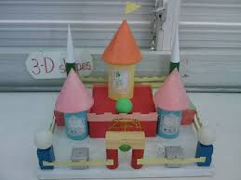  - Look for different 3D shapes inside your home. Practise using mathematical language to describe the shapes. Can you build a tower with them? | Topic  Art/ DT ideas  Choose one of these activities:  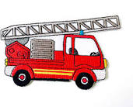  - Create your own emergency vehicle. Think about its features – sirens, hosepipes and ladders, bright colours. You could make your vehicle out of old boxes, bottle top lids and cardboard tubes.  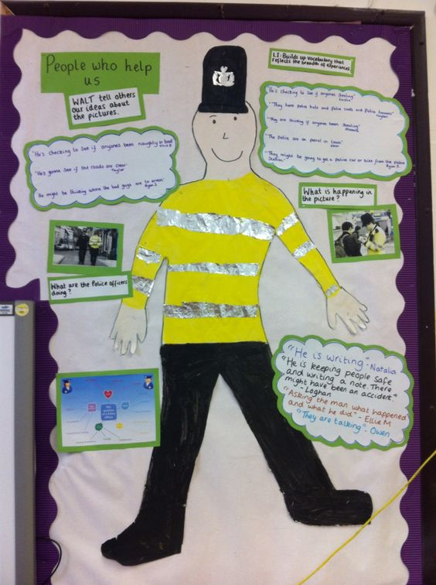  - Create a painting or a collage of someone who helps us.  History:  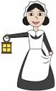  Can you think of different people who help us when we are ill as part of their job? Discuss the jobs, clothes and equipment they use. Nurses have been around for a long time. Find out who Florence Nightingale was. Draw a picture and write a sentence about her.  Music  Listen to the People who help us song. Join in with the words and actions. Can you think of some more actions of your own?  https://www.youtube.com/watch?v=I_3sYFHxJqU
SHAPE \* MERGEFORMAT

