 St. Mary’s Catholic Primary School

Newsletter – Friday 21st April 2023

Tel: 01772 729881   
[www.lea-st-marys.lancs.sch.uk](http://www.lea-st-marys.lancs.sch.uk)  
E-mail [head@lea-st-marys.lancs.sch.uk](mailto:head@lea-st-marys.lancs.sch.uk)

Head Teacher: Mrs. A. Brogden

‘Happy are those who hear the word of God and keep it’ Luke 11:28

Dear Parent/Carer,

It has been wonderful to welcome everyone back to our Summer Term and end the week in some beautiful sunshine.

Thank you to everyone for returning so smartly and may I say you all look wonderful in your summer uniform. Smart, ready to learn and a wonderful representation of our special school.

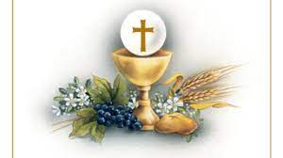

First Holy Communion – 23.4.23

This Sunday a group of pupils from Classes 3 and 4 will take their next step on their own Faith journey as they make their First Holy Communion.

We offer our prayers to:-

*Callum Tennant, Jonah Maduka, Thomas Yates, Joe O’Donnell,  
 Isla Pennington, William Doherty, Henry Doherty, Darcey Chambers,   
Leos Koutsokostas, and Edie Robinson.*

The King’s Coronation

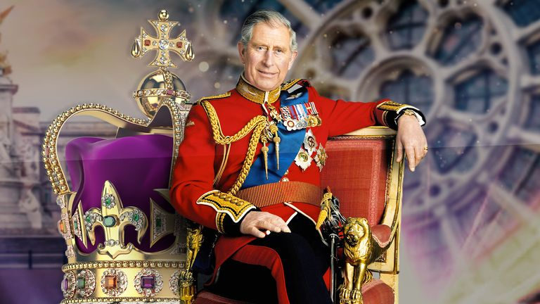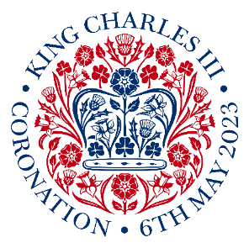

We have already started celebrating and preparing and our first event was a whole school ‘Live Art’ session for staff and pupils.

*To mark the up-and-coming Coronation of King Charles III and to take part in the BBC Children in Need Competition, we all gathered together in the hall on Thursday, to complete a LIVE art event, which was to create a portrait of King Charles III.*

*We were armed with paper, boards and pens and began listening to the artist in residence, Sam Bennett, who taught us step-by-step, how to create the portrait of King Charles III. We watched each part of the clip and then drew our own version on our paper.*

*Now we have completed our portraits, they will be sent off to Sam, in hope he chooses our school as the winners and he will use all of our artwork in a HUGE portrait!*

*Fingers crossed we win!*

*If you would like to have a go at home with family, or if you want to re-draw your portrait, here is the link with all of the information on-*[*https://www.bbcchildreninneed.co.uk/schools/primary-school/bbc-children-in-needs-royally-big-portrait/*](https://www.bbcchildreninneed.co.uk/schools/primary-school/bbc-children-in-needs-royally-big-portrait/)

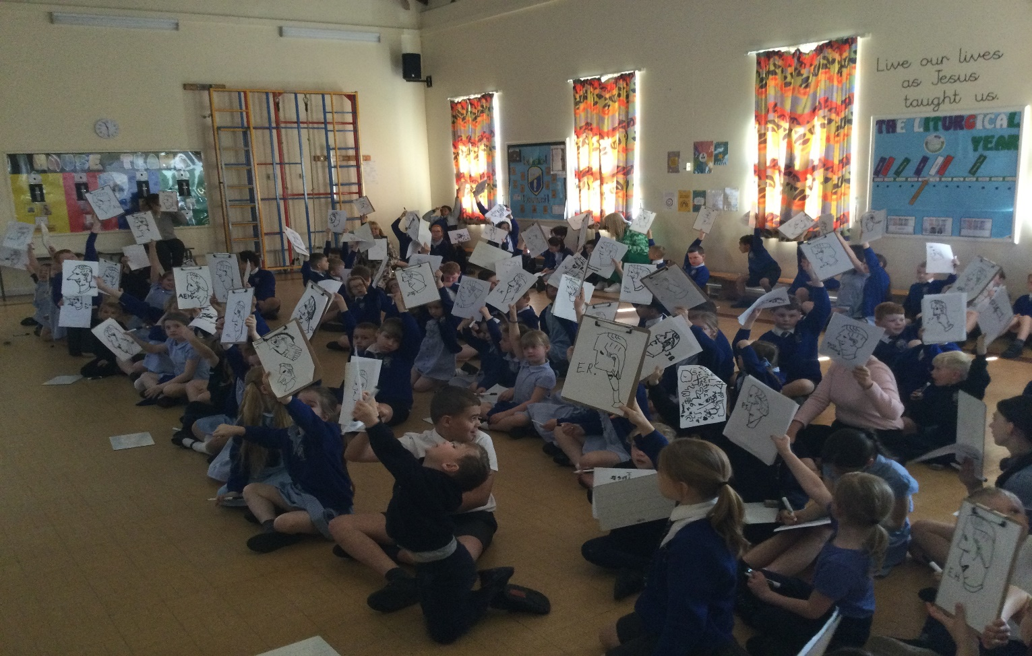*Thank you for your support! Mr C*

Exciting events coming soon ……..

**Thursday 4th of May**

Own clothes day –‘Royal’ clothes – Red, White or Blue, Union Jack or Clothing !!! (No Charge)

Street Party Picnic Lunch – flyer/ order form to follow

After School Club Coronation Disco – See Separate flyer for full details

**Friday 5th May**

Coronation “Arts” Day

Preforming arts- creating and performing poetry

Creating Class art- Each class will study an artist and create their own masterpieces in that style using a range of different materials and mediums.

Class 1: Andy Warhol Class 2: Picasso Class 3: Kandinsky Class 4 : Banksy

Win a Coronation Hamper!!

Tickets are on sale at just £1.00 each and you could win this fantastic Coronation Hamper for your family to share! All the money raised goes directly back to school and we may just be buying everyone a special treat as a keepsake ….Watch this space!

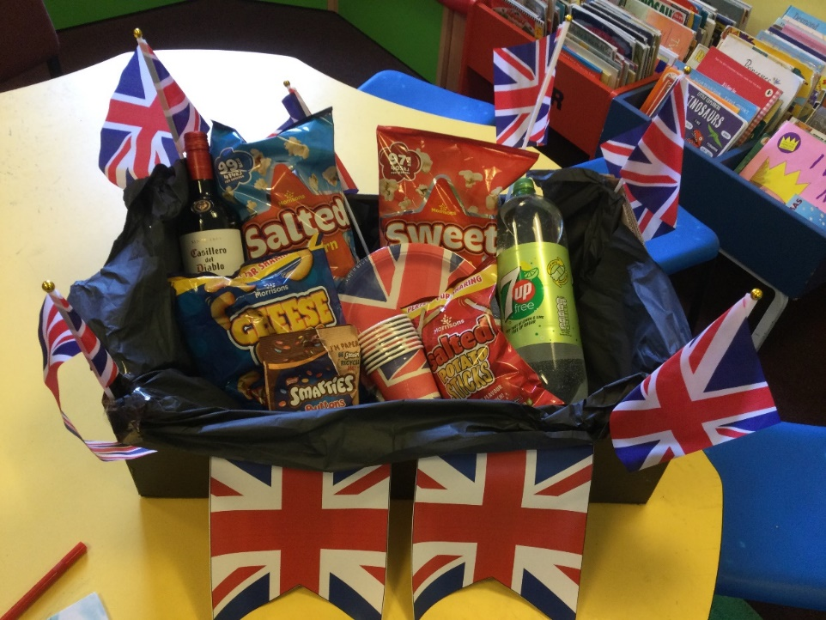

Dates for your Diary

23rd April 2023 - First Holy Communion 9.00 a.m. at St. Mary’s Church

4th May 2023 - Special Street Party Lunch – Own Clothes Day!

After School Club Coronation Disco

5th May 2023 - Coronation “Arts” Day

9th May – 12th May 2023 Key Stage 2 SAT’s

**Celebrations Awards**

|  |  |  |  |
| --- | --- | --- | --- |
|  | **Achievement Award Winner** | **‘EAT’ Award Winner**  **Explore, Active, Think creatively** | **Welfare Award Winner** |
| Class 1 | Thea Koutsokostas | Florence Abram-Jebb | Jaymin Modasia |
| Class 2 | Robert Hanson | Bailey Jenkin | Meredith Holmes |
| Class 3 | Tommy Holland-Bass | Eden Heslop | Nabila Malek |
| Class 4 | Tymon Niezgoda | Alfie Shaw | Freya Stevens |

|  |
| --- |
|  |
|  |

***At St. Mary’s School we***

“Live our lives as Jesus taught us,

Work hard together to achieve our best,   
Respect each other and the world around us,  
Have fun and enjoy learning!”



  
  
  
  
  
  
  
  
  
  
  
  
  
  
  
  
  
  
  
  
  
  
  