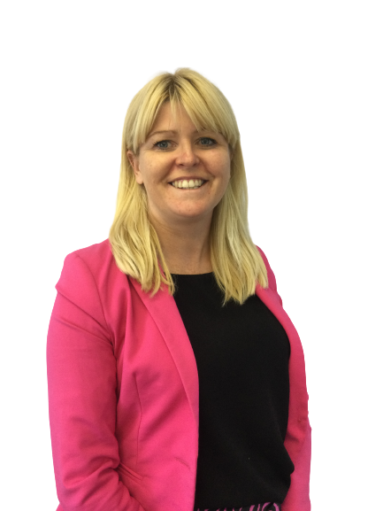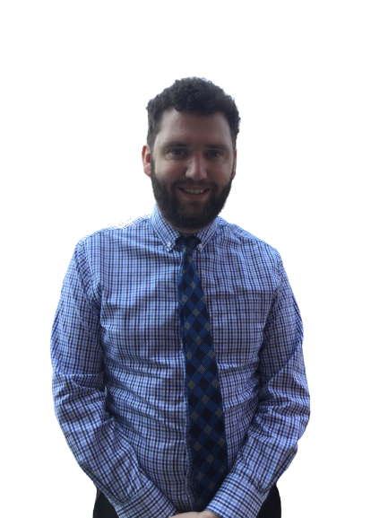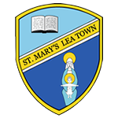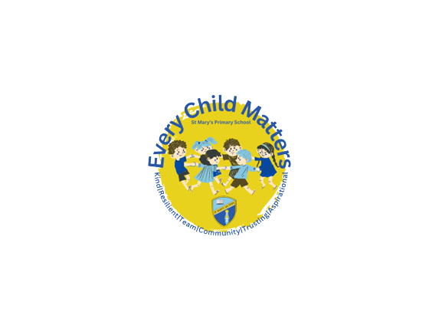0

**Who to speak to if you are concerned about a child at St Mary’s Catholic Primary School**

**Deacon John Cliffe**

**Child Protection Governor**

**Mrs A Brogden**

**Designated Safeguarding Lead**

**Mr M Taylor**

**Back-up Designated Safeguarding Lead**

**At St Mary’s Primary School we are committed to safeguarding and promoting the welfare of children.**

**Keeping Children Safe Is EVERYONE’S Responsibility.**

**You can also report any concerns to the NSPCC.**

**Keeping Children Safe Is EVERYONE’S Responsibility.**

**We are committed to the Safeguarding of all young people and EVERYONE has a duty to safeguard.**

**We can work with families at all stages on the continuum of need.**

**Please ask for further advice or information.**



**Helplines Help for adults concerned about a child**

**Call us on 0808 800 5000**

**Help for children and young people Call Childline on 0800 1111**

