












Instagram
Social Media Platforms
Age Restrictions for
Disclaimer: This resource/information is not intended to encourage social media use and we cannot accept any responsibility for pupils that sign up to social media sites after using this resource/information.
YouTube
BeReal
Reddit
Yubo
Twitch
Snapchat
Discord
Tik Tok
Messenger
Pinterest
Facebook
Twitter
Social Media Platforms
Age Restrictions for
is the minimum age for account holders on these social media sites and apps.

13










Disclaimer: This resource/information is not intended to encourage social media use and we cannot accept any responsibility for pupils that sign up to social media sites after using this resource/information.
is the minimum age for account holders on these social media sites and apps.
PSN Online Account
Xbox
Live
18

Tumblr
Nintendo Online Account
Telegram
Vimeo
WhatsApp
Social Media Platforms
Social Media Platforms
Age Restrictions for
Age Restrictions for
is the minimum age for account holders on these social media sites and apps.

16




They may have:
For further information regarding the video game age restrictions mentioned in this resource, please see the official PEGI website

Lego Series
Among Us
Roblox
Minecraft
Minecraft
Animal Crossing
DiRT Rally
FIFA
Just Dance
Language more suitable for young children
child-like settings
mild forms of violence (non-realistic or with no detail)
some scenes or sounds that could be frightening
comical violence

For example:
For example:
They may have:
Games with a PEGI 7 rating are suitable for ages 7 and above.
Games with a PEGI 3 rating are suitable for all ages.

Video Games
Video Games
Age Restrictions for
Age Restrictions for

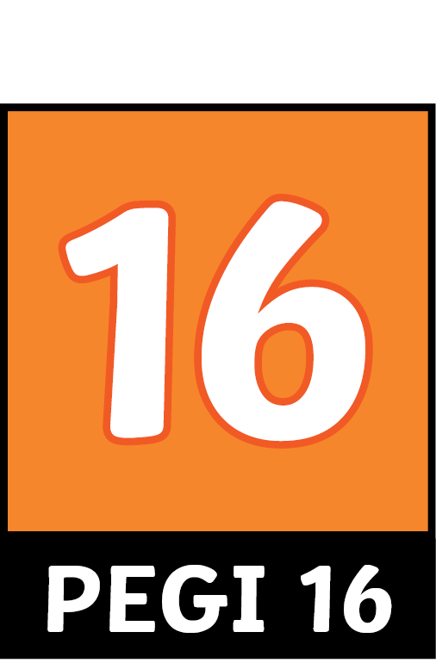

For further information regarding the video game age restrictions mentioned in this resource, please see the official PEGI website
Super Smash Bros. Ultimate
Marvel’s Spider-Man
Halo Infinite
Battlefield 2042
Marvel’s Avengers
Dragon Ball FighterZ
Fortnite
Sims
For example:
For example:
violence and adult content that looks like real life
scenes demonstrating the use of tobacco, alcohol or illegal substances
bad language
mild bad language
gambling
suggestive activities or language

violence of a slightly graphic nature involving fantasy characters

They may have:
They may have:
Games with a PEGI 12 rating are suitable for ages 12 and above.

Games with a PEGI 16 rating are suitable for ages 16 and above.

Age Restrictions for
Age Restrictions for
Video Games
Video Games


Far Cry 3 Blood Dragon

Grand Theft Auto V
Call of Duty: Warzone
For example:
the glamorised use of illegal substances
explicit adult content
extreme violence
They may have:
Games with a PEGI 18 rating are suitable for ages 18 and above.
For further information regarding the video game age restrictions mentioned in this resource, please see the official PEGI website
Video Games
Video Games
Age Restrictions for
Age Restrictions for

