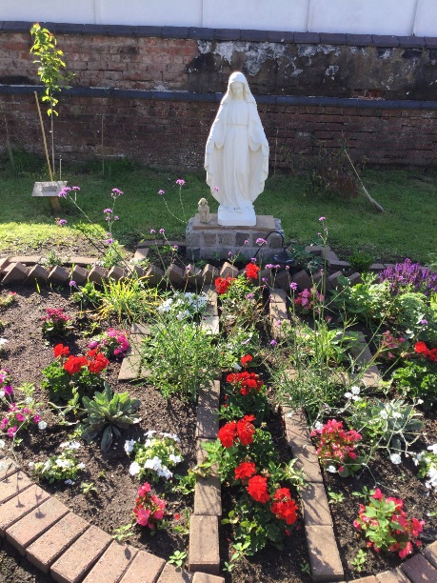 St. Mary’s Catholic Primary School

Newsletter –18th April 2024

**School details**

Tel: 01772 729881   
 [www.lea-st-marys.lancs.sch.uk](http://www.lea-st-marys.lancs.sch.uk)  
 E-mail [head@lea-st-marys.lancs.sch.uk](mailto:head@lea-st-marys.lancs.sch.uk)

Head Teacher: Mrs. A. Brogden

**Our Parish Links**

St. Mary’s Lea Town, Darkinson Lane and

St. Andrew and Blessed George Haydock, Hoyles Lane Cottam.

www.standrewscottam.org.uk

‘Loved and Inspired by Mary ….

We shine and learn as a family of God’

Dear Parents/Carers,

A first full week back in school and once more we settle in school life with lots of exciting new learning.

This Sunday, a group of Pupils from Class 3 will take their next step on their Faith journey as they make their First Holy Communion. We are all very proud of their efforts and commitments throughout their sessions and send our love and prayers for Sunday at St. Mary’s 9.00 am Mass.

We pray for …..

*Bailey, Maxwell, Louisa, Isabella, Jaimie, Freddie, Dougie, Keon, Atonio, Maisie, Jimmy, Isaac, Ellis, William, and from other schools sharing the experience as one group – Summer, Calvin, Benedict, Benjamin, Anvaya and Aadvika*



Staffing News - Retirement

I write to update you, that at the end of this school year, Mrs. Royles will be retiring. I know this has been an incredibly difficult decision for her to make as she has been a special part of our school family and given 26 years service!! I am sure you will join me in offering her every happiness in her Retirement and in due course we will celebrate her within our School Mass.

Recruitment processes will take place and we shall update you as is relevant.

17.4.24 – STEAM session – Class 3 BAE Systems

Wednesday 17th April 2024

In Class 3, we were very lucky to have 2 visitors from BAE Systems join us to help us learn about coding, how to create a programme for a robot to follow and then test out our programmes on a real robot!

Chris and Steve joined us and started off by explaining what they do at BAE Systems, we then completed a Code-Cracking exercise, where we had to use a code to unlock the secret word. Next, we used a cypher to unlock the next phrase to use in our team, using colours and the alphabet to crack the code. Finally, we were able to write our own code and programme for the robot to follow, hoping to get around the track the quickest. Well Done to Team Hot Shots (Joe, Nabila, Nio, Ellis and Keon), who were quickest around the track.

Joe- "it was AMAZING!"

Bailey- "I liked it when we could control the robot around the track".

Louisa- "I liked when we worked as a team to solve the code with the colours".

We would like to say a HUGE thank you to Steve and Chris for joining us as well as BAE Systems also. Class 4 have a session booked in with BAE Systems in June- check out the details of that, as well as pictures and a write-up soon!

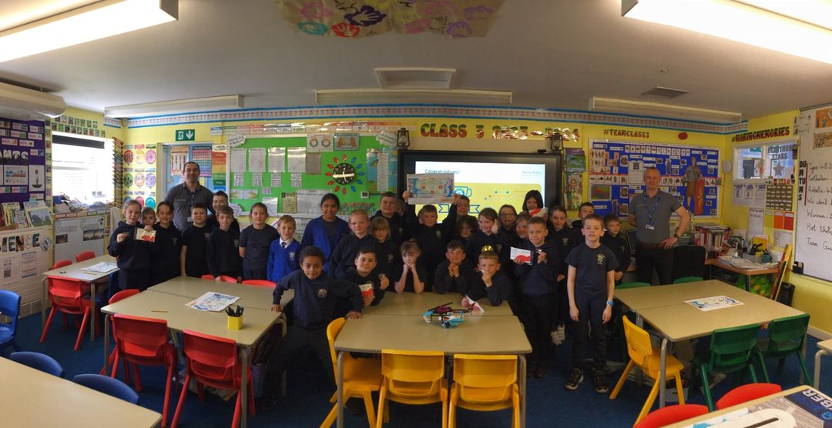

FOSM- Coffee and Chat – 23.4.24

The FOSM are always welcoming new members and support, so we would like to offer a Coffee and Chat session on **Tuesday 23rd at 8.45 here in school** – This is just an informal chat open to EVERYONE – Parents, Grandparents, Aunts, Uncles or simply friends – You are all welcome . It may be you would love to be involved behind the scenes – shopping? Wrapping? You may wish to be a ‘formal’ member or help out at events.

The more members the better, as many hands make light work- we would be so grateful as EVERY penny raised really does make a difference.

The FOSM have already contributed to a full set of IPADs this year and given every class £100 towards a visit, visitor or experience!! Classes one and two have used his to cover the entire cost of transport to the zoo!

Thank you to everyone that supported us.

Our goal is to put a fixed amount into our Long term pot with the goal of getting an outdoor classroom and put a fixed amount back into school for experiences and equipment!

We will be holding an AGM meeting in April/ May to nominate a

Chair

Treasurer

Secretary

So please look out for this date to be shared soon!

Helping Hands

With the support or St. Mary’s Parish, we have a created a ‘***Helping Hands Fund’*** – This means we have a stock of tinned food/ non-perishable items and toiletries …So, if you ever need a little ‘**Helping Hand’** please just ask and we can gladly put a pack together.

Sports Clubs and Activities

All lunchtime and after school sports clubs and activities have started…If you didn’t book on and want to check if we have any spaces please contact the school office

Lunch Menu

The new menu is in place, and as per the text yesterday, we now also offer sandwiches- Mon- Thurs – Ham, Cheese, Tuna and Egg and on a Friday – Ham, Cheese, Tuna or Jam! These will be served with the potato option and/or salad and a dessert.

Dates for your diary

23.4.24 - FOSM Coffee and Chat at 8.45 am

24.4.24 - Key stage one trip to Blackpool Zoo

25.4.24 Wear Red Day – St Mark’s Feast Day

**Celebrations Awards**

|  |  |  |  |
| --- | --- | --- | --- |
|  | **Faith in Action Award** | **‘EAT’ Award Winner**  **Explore, Active, Think creatively** | **Welfare Award Winner** |
| Class 1 | Martha Robinson | Diana Stec | Ria Kaur |
| Class 2 | Oliver Lawson | Pippa Doherty |
| Class 3 | Nio Qereqeretabua | Meeya Patel | Jamie Bass |
| Class 4 | Tommy Holland-Bass | Freya Stevens |

***At St. Mary’s School we***

“Live our lives as Jesus taught us,

Work hard together to achieve our best,   
Respect each other and the world around us,  
Have fun and enjoy learning!”

 