  
St. Mary’s Catholic Primary School

Newsletter – Friday 22nd November 2019

Tel: 01772 729881 [www.lea-st-marys.lancs.sch.uk](http://www.lea-st-marys.lancs.sch.uk)   
 E-mail head@lea-st-marys.lancs.sch.uk

Associate HeadTeacher: Mrs. A. Charnley

‘Happy are those who hear the word of God and keep it’ Luke 11:28

Dear Parent/Carer,

Mrs Charnley’s Message

The highlight of this week has to be our extended learning day to mark the end of the Year of Eucharist. Deacon John joined the school, with fantastic reading from our Year 2 children, with Exposition of the Blessed Sacrament. This is always a special time we can be close to God in our prayer life. The day then continued with sessions from Ruth and the Metanoia group, prayer writing for our Earth and so much more. Thank you everyone, for reminding us all, that our world really is a wonderful place, filled with hope and love and that it truly is the responsibility of each one of us to care for it. The dances you created with Rachel were amazing. With such beautiful singing and acting I know we were all moved to think about how our actions can help to save our world! Thank you to all the staff who continue to work tirelessly to make St Mary’s a special place to show love and learn together.

Celebration to mark the end of The Year of the Eucharist –

We had a wonderful day together on Thursday to celebrate the end of The Year of the Eucharist. We began with a special exposition of the Blessed Sacrament in Church led by Class 2 who read beautifully. Thank you to the parents and families who joined us. We then spent the day undertaking thought provoking activities which allowed us to reflect on God's gift of creation. Celebrated in the Eucharist. This was paired with Pope Francis' call to action to find a different way of living and look after our common home, the world he gave us. The children took part in dance workshops creating dances which were then linked in our final assembly. The dances told the story of creation, destruction of and then hope for the replenishing and rebuilding of our Earthly home.

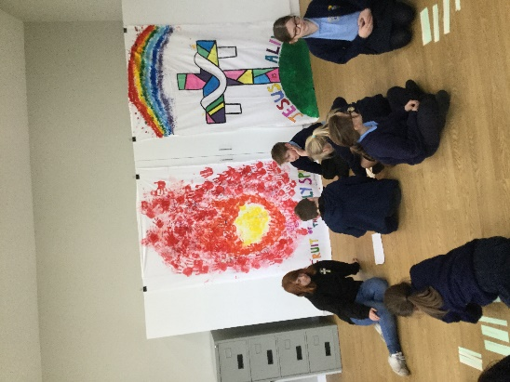 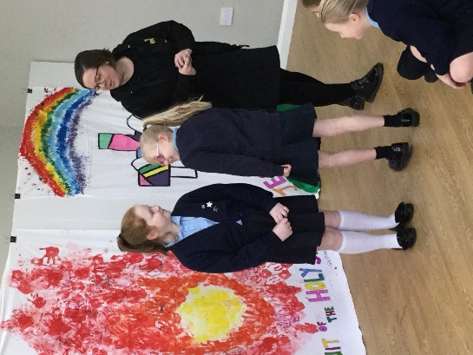 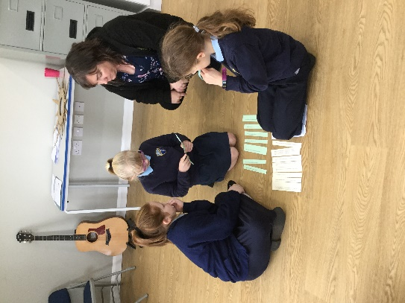

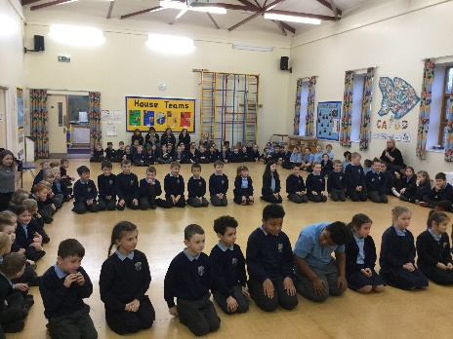 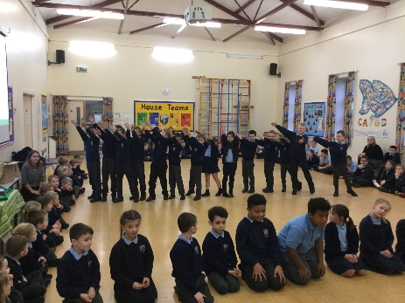 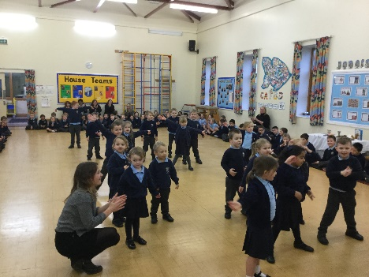

Everyone visited a special prayer station in school to create a prayer, these can be seen on our prayer tree in reception. The children also enjoyed arts and crafts activities which link to the upcoming feast day of Christ the King. We all attended workshops from The Metanoia Project, who operate the Seekers youth group for our older children every Friday. A special note of thanks to Canon Adrian and the parish who supported us financially with this activity.

Parking and Safety

Thank you for continuing to support us as we try to ensure the safety of all our pupils. Please don’t use the school driveway to turn around. It is important that families park in the Smiths Arms car park at both morning drop off and home time, in order to maintain the safety of all of our children, please use the car park responsibly by parking inside the lines and being courteous to other users.

Christingle – Sunday 1st December at 9.00 a.m. Mass  
  
To mark the start of Advent the children will make a Christingle in Children’s Liturgy. A Christingle is a decorated orange to represent God’s world. When we have decorated our Christingles we will then show them to everyone in church. We would love you to join us at the 9.00 a.m. Mass. Thank you.

Raffle Tickets- St. Mary’s Church

St. Mary’s Annual Christmas Raffle tickets have arrived and are priced at 25p each or £1.00 per booklet with some fantastic prizes available. A first prize of £50, with other prizes including a turkey, Christmas cake and lots of bottles and chocolates!!

The funds raised will be donated to our school and to St Savio School in Kerala where Sister Litty taught.

Each family will come home with 2 booklets and we would be most grateful if you could return tickets with the completed slips and monies to the Office. Any unwanted tickets can be returned to the School Office.

E.A.T learning!

EAT - At the end of this term we will be holding our termly draw for our EAT home learning. The box is available in the foyer for you to drop your EAT notes into. There are spare sheets available and these are also available as a download on your child's class page.

Advent Service, Christmas Light Switch on and Bingo - 2.12.19

On Monday 2nd December we will have our annual Advent Service and Christmas Light switch on. All pupils have brought home an individual letter with all timings and arrangements. After the Service the FOSM have organised Christmas Bingo.

“Prickly Hay” – Class 1 and 2 Nativity

Our Key Stage 1 Nativity “Prickly Hay” takes place on Tuesday 10th December. Tickets are priced at £1.00 for adults and 50p for children. Please send any money into school in an envelope with your request for tickets (2.00 p.m. / 6.00 p.m.) For health and Safety reasons tickets are sold on a first come first served basis so please put your request in early to avoid disappointment.

Request from Miss Berry  
  
As part of our ‘Toys’ topic, Class 1 are learning to sort old and new toys. Please let me know if you have any older toys. We would be especially excited to see some metal toys. Thank you.

Poor Weather

As the Weather begins to change could we ask that all children have a suitable coat and/ or waterproof in school for breaks and lunchtime. Occasionally PE lessons will take place outside and children will need a spare jumper and, in line with our uniform policy, may wear Navy jogging bottoms. Thank you for your co-operation.

Big School Adventures – Thursdays @ 1.15 p.m.



This is a free session for pre-school children aged 3 and above and is an invaluable opportunity for children to come along and experience school life. It has been very successful and has really grown. It has had a very positive impact on the pupils who have joined reception class enabling a very smooth transition into school. Please ask if you need any further information.

Dates to remember

Tuesday 26th November – Nasal Flu Immunisations   
Wednesday 27th- 29th November – Class 4 Hothersall Logde Residential   
Monday 2nd December 4.15 p.m. Advent Service–Christmas Tree Lights switch on & Bingo  
Wednesday 4th December - CAFOD Advent Service, St Anthony’s Church at 6.00 p.m.  
Monday 9th December – Pantomime   
Tuesday 10th December – KS1 Nativity 2.00 p.m. & 6.00 p.m.  
Monday 16th December – Christmas Lunch  
Every Friday 2.45 p.m. Celebration Assembly -everyone welcome

**Celebrations Awards**

|  |  |  |
| --- | --- | --- |
|  | **Achievement Award Winner** | **‘EAT’ Award Winner**  **Explore, Active, think creatively** |
| Class 1 | Violet Jameson | Darcey Chambers |
| Class 2 | Macie Dixon | Harry Bass |
| Class 3 | Penny Robinson | Oliver Hooper |
| Class 4 | Elise Phillips | Lucas Worrall |
|  | **Welfare – Lunch Time Award** | |
|  | **Key Stage One** | **Key Stage Two** |
|  | Rosie Robinson | Rachel Kennedy |

***At St. Mary’s School we***

“Live our lives as Jesus taught us,

Work hard together to achieve our best,   
Respect each other and the world around us,  
Have fun and enjoy learning!”

