  
 St. Mary’s Catholic Primary School

Newsletter – Friday 11th June 2021

Tel: 01772 729881   
[www.lea-st-marys.lancs.sch.uk](http://www.lea-st-marys.lancs.sch.uk)  
 E-mail [head@lea-st-marys.lancs.sch.uk](mailto:head@lea-st-marys.lancs.sch.uk)

Head Teacher: Mrs. A. Brogden

‘Happy are those who hear the word of God and keep it’ Luke 11:28

Dear Parent/Carer,

It was lovely to welcome everyone back to school this week after our half term and enjoy some glorious weather together.  We had to close Bubble 4 this week and I understand this can put additional pressure on our families but as you will appreciate this is unavoidable as we are driven by safety. May I take this opportunity to thank you for your ongoing support with all our additional safety measures and routines. Sadly cases continue to be recorded and on the rise and as such we must adhere to guidance and risk assessments.

This week we welcomed two new members to our school family: *Welcome to Nabila Malek and Chloe Gildea*

Garden of Prayer and Friendship

I am sure you will agree the Garden of Prayer and Friendship looks beautiful and once again may I thank everyone for their time, donations of plants and the many hours spent digging and watering.

This week our beautiful statue of Mary has arrived so we look forward to planning our official Blessing with Deacon John as soon as we are able to do so.

Vacancy – Cleaner 20 Hours Per Week

We are looking for an experienced cleaner to join our school team from June. If you would like a copy of the job description and/ or further information please contact Mrs. Lofthouse.

Forest Schools - CAN YOU HELP US ???

As we have shared previously, we are very excited to be developing our Forest Schools status with Mrs. Jennings. Canon Adrian and the Parish of St. Mary's have supported us considerably with a donation toward a brand new canopy and in the near future we will have some exciting Forest School items for sale, plus some exciting events to help us fundraise!!

What we really need now is some willing volunteers to help us remove weeds and rotten wood so we can prepare the area…..**Thursday 24th June….in the morning!**

Could you help ?             Do you have few hours to spare ? Do you have spare tools ?

We need to weed the area and remove all the rotten wood!

If you could help please email jennings@lea-st-marys.lancs.sch.uk or call us at school!

We need to turn this…..

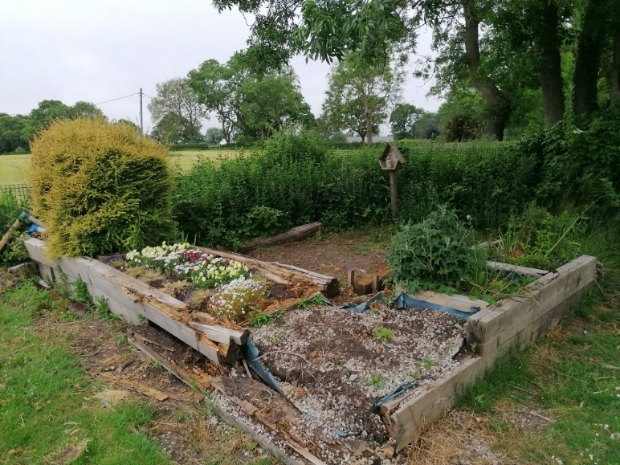

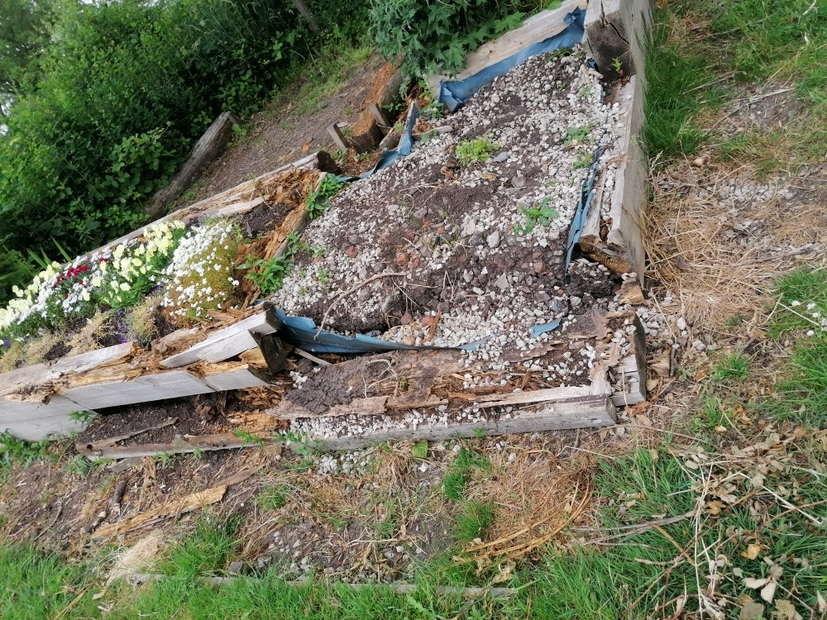

Into this …

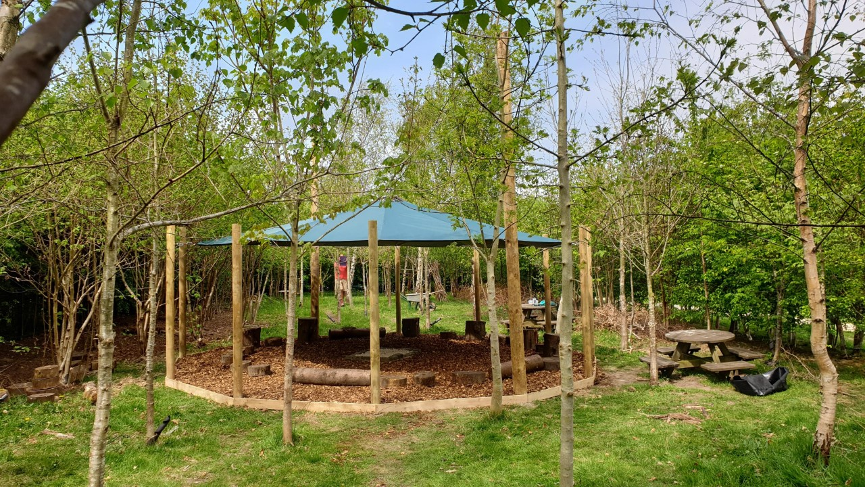

Class 4 Fundraising...Coming soon.....

Cake Sale – Monday 14th June

Non Uniform day – Friday 18th June £1.00

Big School Adventures

Big School adventures takes place every Thursday from 1.15 -3.15 pm with rigid safety measures in place as previously.

**Numbers are strictly limited and places must be pre booked each week.**

Have a look at our weekly activities which can be found under the Pupils tab of our school website!!

Should you require any further information or to book a place please call 01772 729881.

Dates for your diary:

Monday 14th June - Cake Sale

Friday 18th June - Non Uniform day £1.00

Thursday 24th June - Forest Schools Volunteer day – clearing of old space

Friday 25th June - Non Uniform day – Wear ‘forest’ colours or dress as a woodland  
 animal £1.00

Monday 28th June - World Faiths Week - Islam

Friday 2nd July - Sponsored Fun Run – Details to follow!

**Celebrations Awards**

|  |  |  |  |
| --- | --- | --- | --- |
|  | **Achievement Award Winner** | **‘EAT’ Award Winner**  **Explore, Active, think creatively** | **Welfare Award Winner** |
| Class 1 | Harry Shaw | Esme Knott | Louisa Nelson |
| Class 2 | Nabila Malek | Deondre Thompson | Joe O’Donnell |
| Class 3 | Dane Lewis | Olivia Leigh | Chloe Moore |
| Class 4 | Cherry Davis | Rachel Kennedy | George Stevens |

***At St. Mary’s School we***

“Live our lives as Jesus taught us,

Work hard together to achieve our best,   
Respect each other and the world around us,  
Have fun and enjoy learning!”