 St. Mary’s Catholic Primary School

Newsletter – Friday 14th January 2022

Tel: 01772 729881   
[www.lea-st-marys.lancs.sch.uk](http://www.lea-st-marys.lancs.sch.uk)  
 E-mail [head@lea-st-marys.lancs.sch.uk](mailto:head@lea-st-marys.lancs.sch.uk)

Head Teacher: Mrs. A. Brogden

‘Happy are those who hear the word of God and keep it’ Luke 11:28

Dear Parent/Carer,

Our first full week back in school and we have been busy, as ever learning lots of new things!

It was lovely to also see everyone in their own clothes on Thursday helping us to raise funds for school.

We are now within the transitional period for our new uniform. All pupils are welcome to move to the new uniform from now and will be required to wear the new uniform from September 2022. Our uniform suppliers will continue to offer 'pop up shops' within school and, as ever should you require any support, advice or have any questions  do please get in touch.

Covid- 19- Important information

I issued a letter on Monday 10th January which contains important information in regard to the Temporary Suspension of Confirmatory PCR’s and the requirement for 7 day LFT testing for close contacts. A copy of this can also be found on our school website.

When sending in evidence of a Lateral Flow we require the NHS notification of result as shown below.

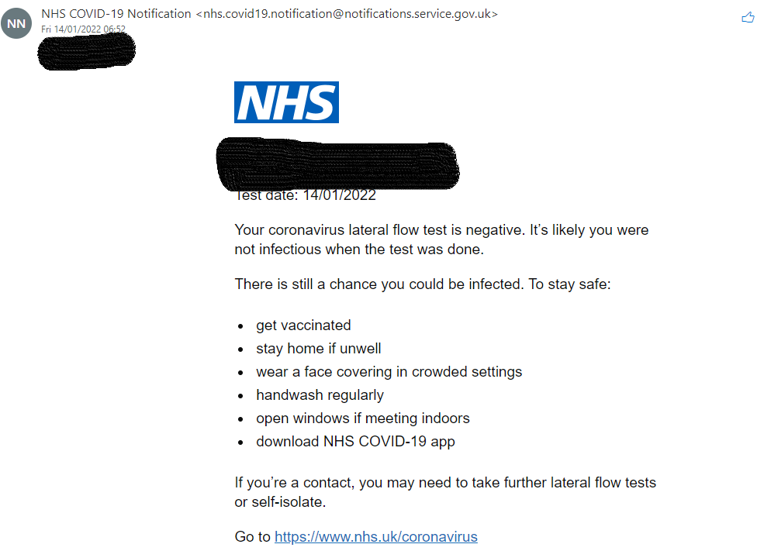

You report your Lateral flow result at <https://www.gov.uk/report-covid19-result>

Results must be emailed to school on [head@lea-st-marys.lancs.sch.uk](mailto:head@lea-st-marys.lancs.sch.uk) and [bursar@lea-st-marys.lancs.sch.uk](mailto:bursar@lea-st-marys.lancs.sch.uk) EACH morning for 7 days. Pupils cannot attend without this information.

**We cannot accept photographs of the LFT device.**

**For those identified as direct contacts we will require results to be shared for 7 days.**

Please inform us at school if your child(ren) or any household member tests positive for Covid- 19 and we can provide advice.

RE HRSE scheme – Life to the full

Your child will have brought home a letter and Parental leaflet from Mrs. Williams our RE Coordinator in regard to our HRSE scheme ‘Life to the full’. Copies of this letter along with a parental leaflet have also been shared on our school website. Families are invited to view materials and give feedback. Full details of this consolation opportunity can be found within the letter. Should you require any support please do contact Mrs. Williams on williams@lea-st-marys.lancs.sch.uk

Friends of St Mary's - FOSM

Do you have any unwanted gifts – Bath sets, games etc. which you would be happy to donate to FOSM for future bric a brac sales. Please drop these off in reception.

Non Uniform Day

Thank you for your support with our Non Uniform day we raised £98.00 for school funds.

Big School Adventures

Big School Adventures takes place 1.15 – 3.15 pm each week. Places are strictly limited and must be booked in advance.

**Celebrations Awards**

|  |  |  |  |
| --- | --- | --- | --- |
|  | **Achievement Award Winner** | **‘EAT’ Award Winner**  **Explore, Active, Think creatively** | **Welfare Award Winner** |
| Class 1 | William McMillan | Keon Bruney | Jade Beresford |
| Class 2 | Ellis Leigh | Harry Davies | Nabila Malek |
| Class 3 | Ella Mullarkey | Elliott Reid | Elliott Capper |
| Class 4 | Oliver Hooper | Isla Kilshaw | Finnley Foxall-Holmes |

***At St. Mary’s School we***

“Live our lives as Jesus taught us,

Work hard together to achieve our best,   
Respect each other and the world around us,  
Have fun and enjoy learning!”