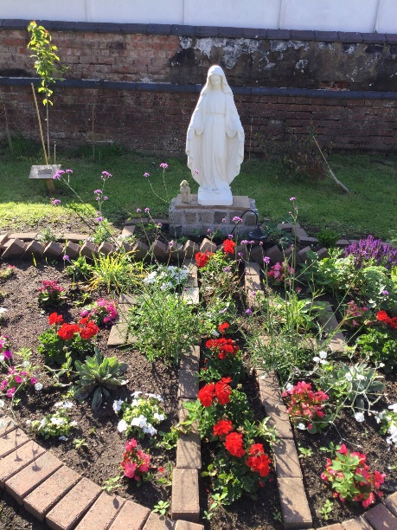 St. Mary’s Catholic Primary School

Newsletter –26th April 2024

**School details**

Tel: 01772 729881   
 [www.lea-st-marys.lancs.sch.uk](http://www.lea-st-marys.lancs.sch.uk)  
 E-mail [head@lea-st-marys.lancs.sch.uk](mailto:head@lea-st-marys.lancs.sch.uk)

Head Teacher: Mrs. A. Brogden

**Our Parish Links**

St. Mary’s Lea Town, Darkinson Lane and

St. Andrew and Blessed George Haydock, Hoyles Lane Cottam.

www.standrewscottam.org.uk

‘Loved and Inspired by Mary ….

We shine and learn as a family of God’

Dear Parents/Carers,

A first full week back in school and once more we settle in school life with lots of exciting new learning.

First Holy Communion – 21.4.24

On Sunday a group of pupils made their First Holy Communion and this was a very special day for them all.

*Please could you pass on my congratulations to the children. They have been wonderful. I have enjoyed helping them to prepare. They have so much to be proud of. Super behaviour, super attitudes and super good thinking. They were fantastic yesterday! Everything done with a smile- wow!! Best wishes,Jackie*

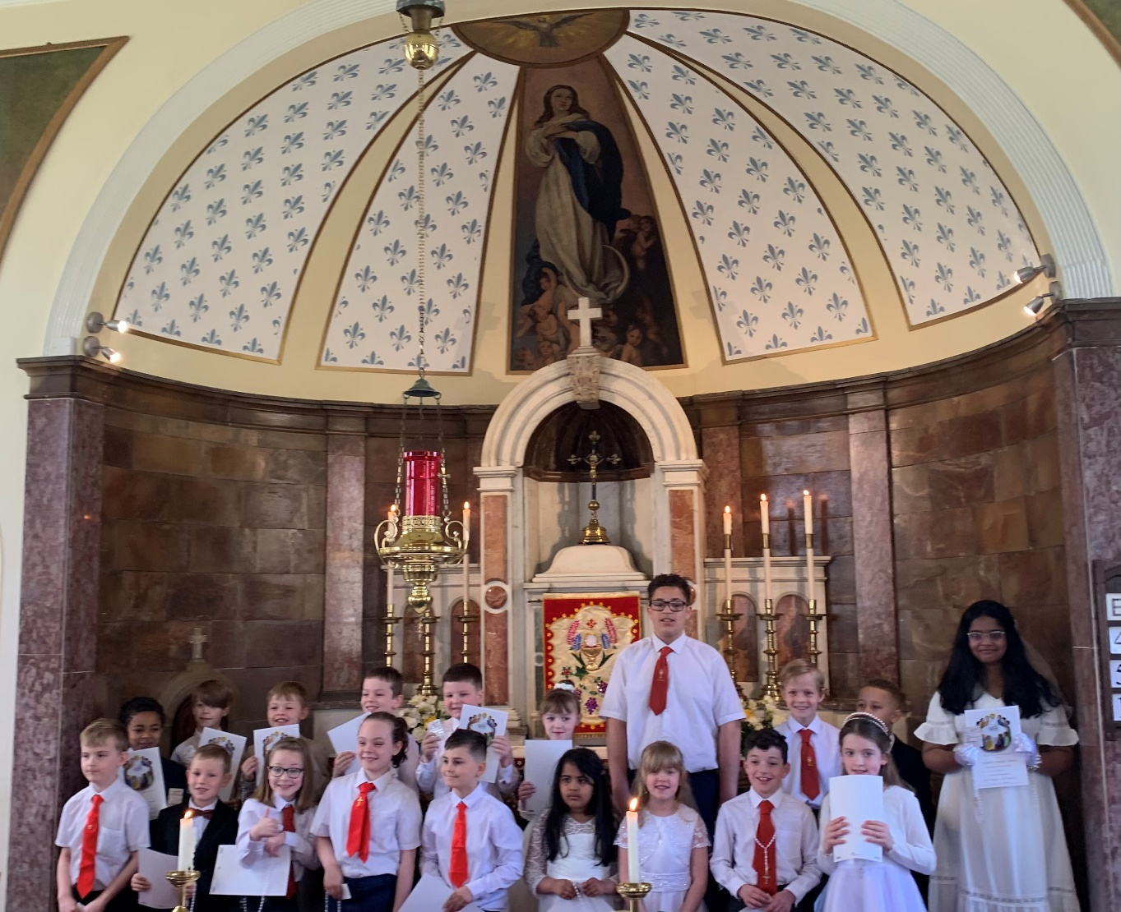

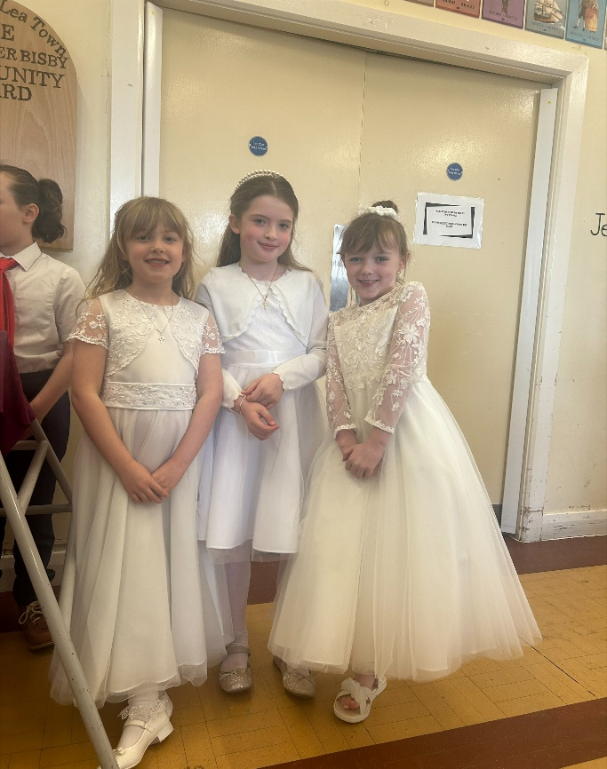

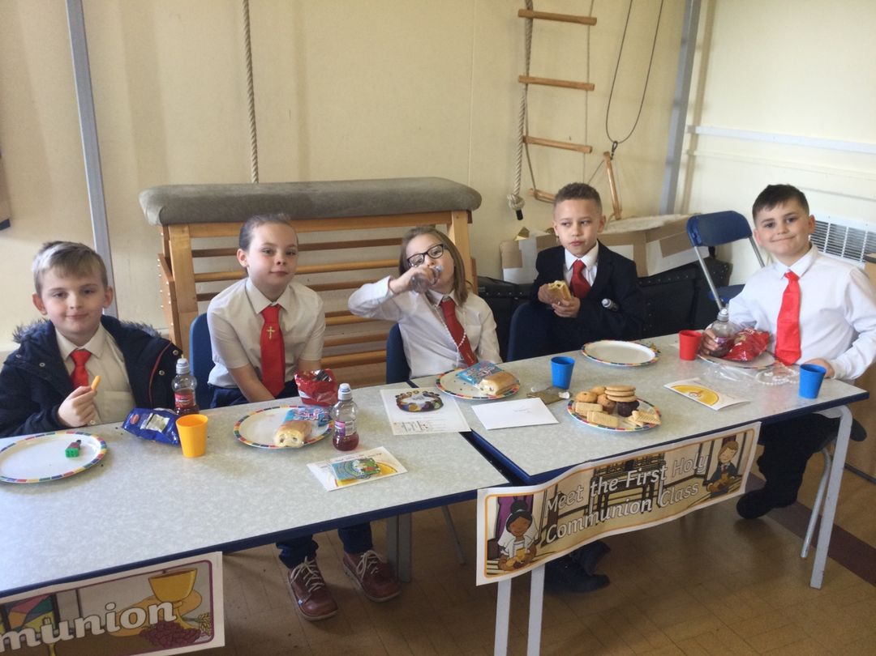

Congratualations

*Bailey, Maxwell, Louisa, Isabella, Jaimie, Freddie, Dougie, Keon, Atonio, Maisie, Jimmy, Isaac, Ellis, William, and from other schools sharing the experience as one group – Summer, Calvin, Benedict, Benjamin, Anvaya and Aadvika*

Curling – 23.4.24

On Tuesday a group of pupils from Class 4 attended West View Leisure Centre to take park in a Curling competition and what a Fantastic result ……..They came FIRST PLACE!

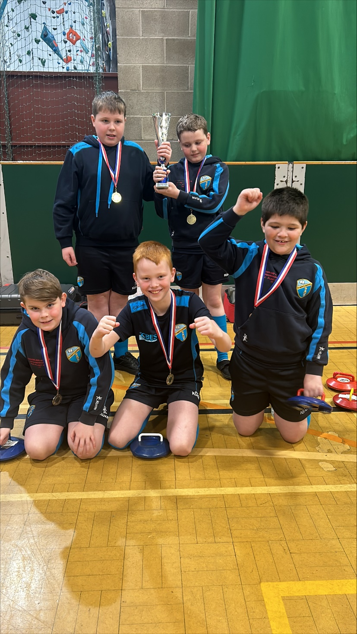

“*It was good as we all worked together as a really good team” William Doherty*

*“It was amazing because although we lost some games we kept trying and trying and we won!!” Nicholas Biela- Barnes*

*“It was actually pretty fun and it was my first time- I didn’t know what to do but my friends were there to help me and it was really fun!” Jack Moyes*

*“ It was very fun- even when we lost everyone was trying their best!” Noah Foxall - Holmes*

*“ I have enjoyed the Curling competition as there were many teams and it was competitive. We were overjoyed when we found out we came in first place!” James Picking,*

Blackpool Zoo – 24.4.24

On Wednesday Classes 1 and 2 had a fantastic trip to the Zoo!! We were so lucky to be blessed with beautiful weather and a fantastic time was had by all!

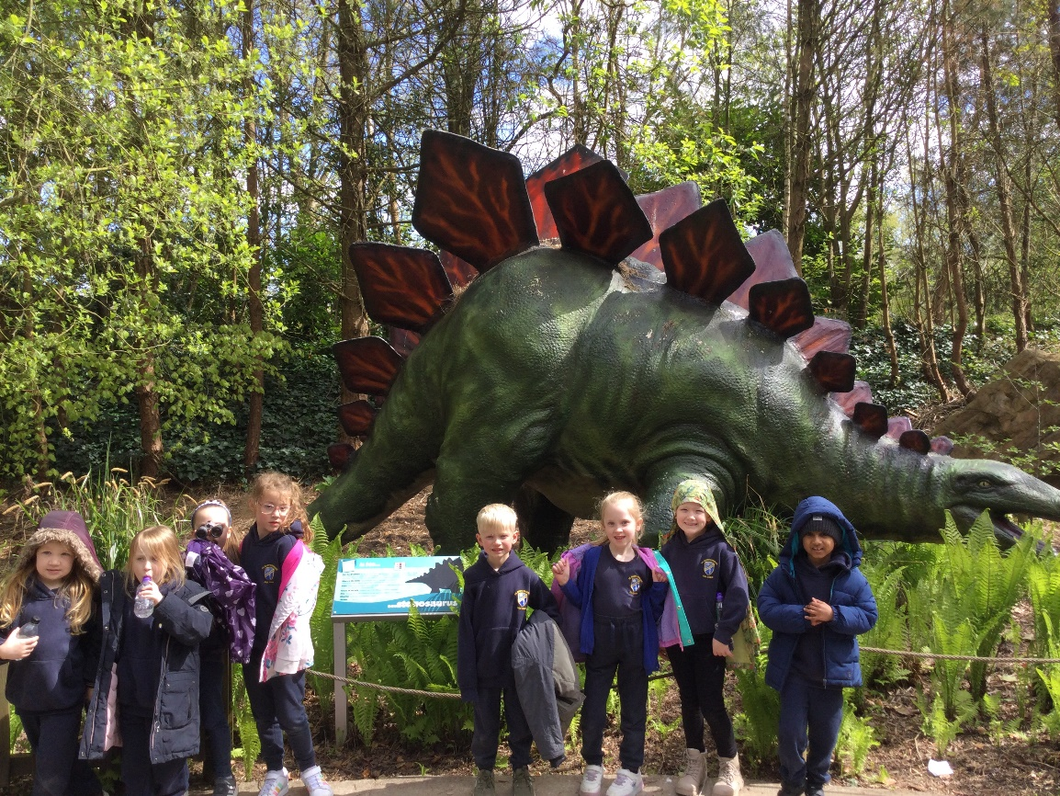We heard so many say “ This is the best day ever” and “ This is the best day of my life!” it was an absolute pleasure to see the pupils behaving beautiful, having fun and gaining so much from this experience. Thank you again to the FOSM for the contribution which meant the cost was reduced for all families.

*“ I loved seeing the birds and learning about the animals” Maisie Wilson*

*I liked it because it was very fun!” Matthew Williams*

*“ I liked it because I sat next to my friends and the bus and I had the best day!” Reggie Hall*

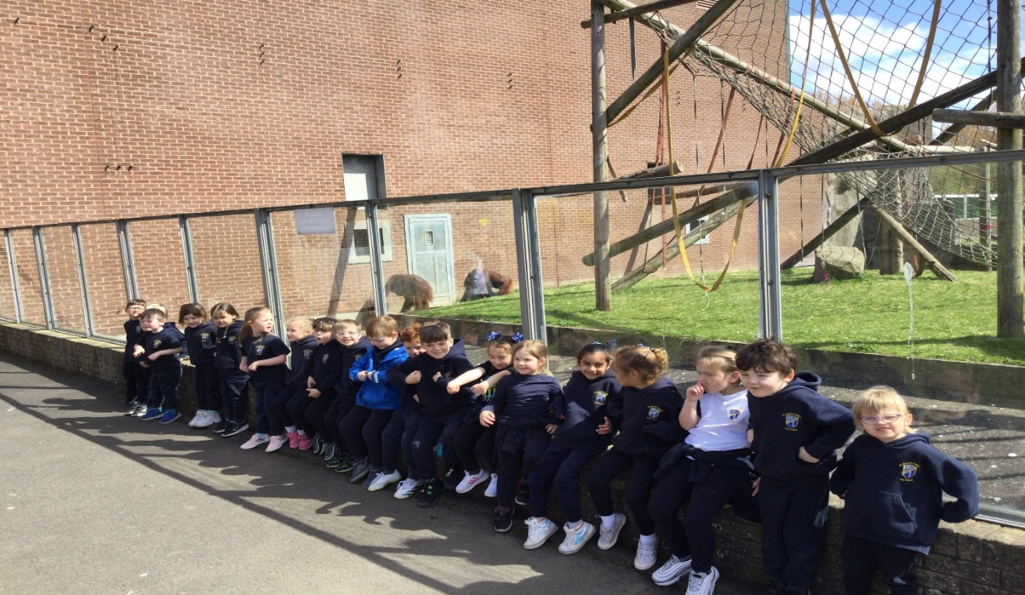

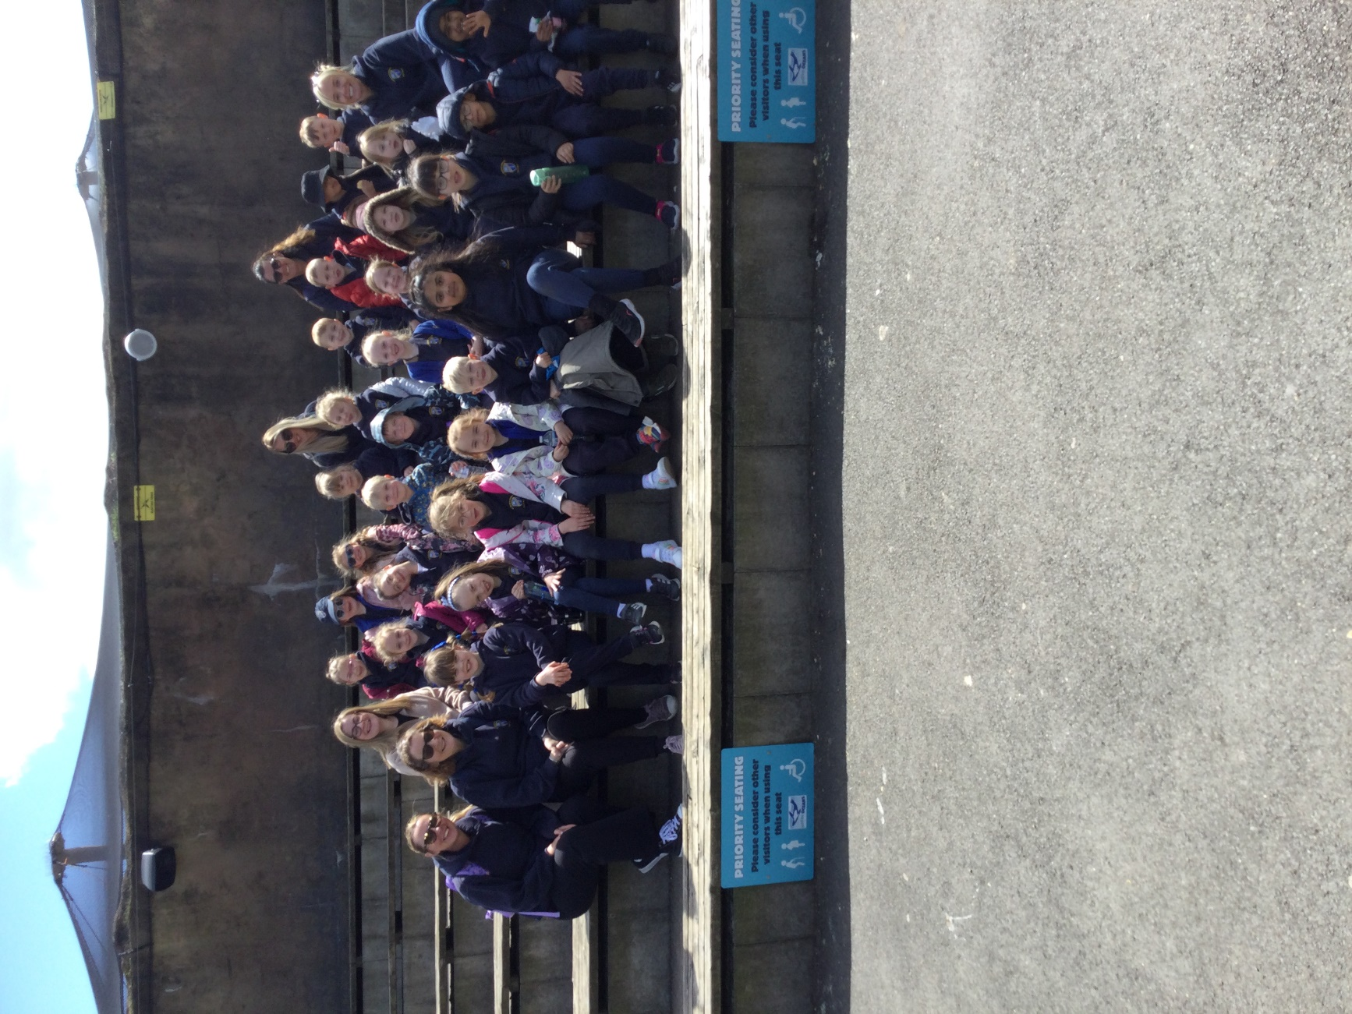

St. Mark’s Feast Day

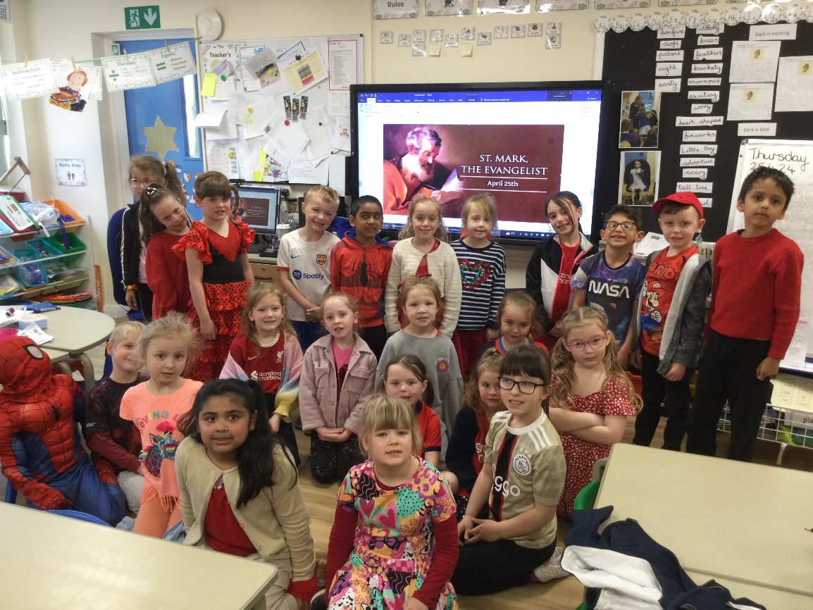

On Thursday 25th April, the whole school celebrated the Feast of St Mark. As well as coming into school in our best red outfits- the colour of Mark house team- each class also learnt facts about this special Saint.

Can your child remember?

What animal often represents Saint Mark?

Where is Saint Mark the Patron Saint of?

In which Testament of the Bible is the book of Mark written?

Tell your class teacher any of your facts to get some house points!

The Woodland Trust – Tree planting

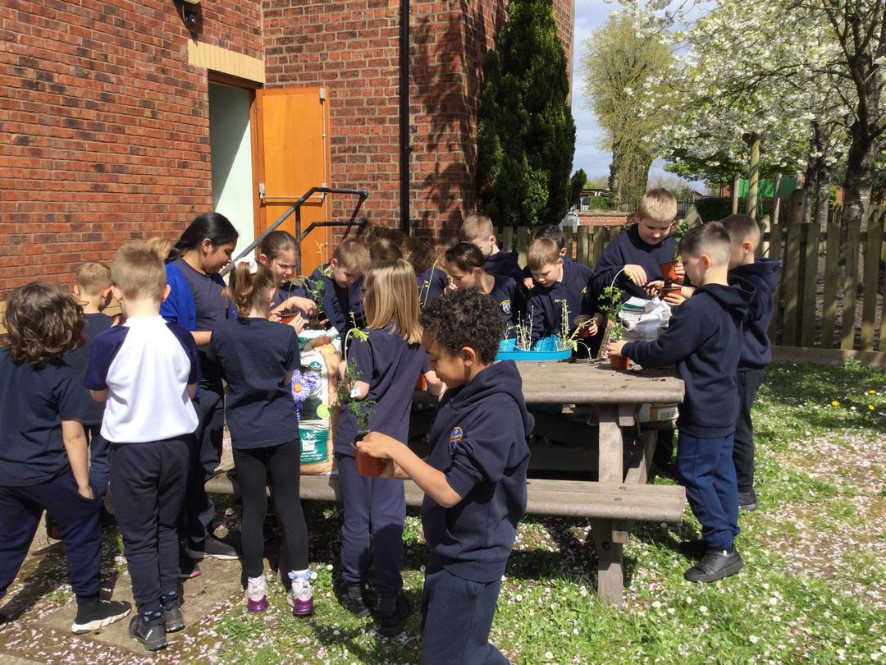

*Dear all,*

*Tonight, your child/children will be coming home with a sapling in a pot for them to plant at home in their garden (or into a larger plant pot) to help support the work of the Woodland Trust.*

*Currently, the Woodland Trust is over 50% behind their target of planting trees across the UK to help combat climate change, create more natural spaces and to provide homes for animals, birds and insects in the future. So, to give them a helping hand in reaching their target, and to practice some of our skills in school and at home, we have been given a number of saplings as a school.*

*Class 3 have potted over 100 saplings for our school, with over 8 different varieties of trees available to us from the Woodland Trust and local growers. All we ask you to do is either plant it into your garden at home or into a larger pot until it grows bigger and water it to look after it.*

*If you have any questions, please feel free to come and speak to me.*

*Thank you for your support.*

*Mr C and Class 3*

FOSM- Coffee and Chat – 23.4.24

The FOSM held Their Coffee and Chat session and thank you to all who came along. The next Coffee and Chat will take place on **Tuesday 30th April at 5.00 pm in the Smiths Arms**

The AGM will take place on **Wednesday 8th May at 8.45 am**

Save the Dates………

**Sports Day and Summer Show and stalls – 25.6.24 – 3.15 onwards (Reserve 2.7.24)**

**Tombola’s, raffles, stall, refreshments and family fun PLUS a performance from EVERY class!**

**Non Uniform**

**13.6.24 - Own clothes bring a Sweet treat for the Tombola**

**20.06.24 – Own clothes bring a bottle for the Bottle Tombola**

**St Mary’s Got Talent- coming soon!!!!!!!**

**Super exciting it is nearly that time again - Live show 11.7.24**

**Non Uniform**

**4.7.24 – Own clothes Bring a chocolate item – Tombola**

Our aim is to put a fixed amount into our Long term pot with the goal of getting an outdoor classroom, and put a fixed amount back into school for experiences and equipment!

Helping Hands

With the support or St. Mary’s Parish, we have a created a ‘***Helping Hands Fund’*** – This means we have a stock of tinned food/ non-perishable items and toiletries …So, if you ever need a little ‘**Helping Hand’** please just ask and we can gladly put a pack together.

Dates for your diary

Wednesday 1st May 2024 – Reception Year Vision Screening in school

W/C 13th May – Year 6 SATS week

See above for other dates in more detail

**Celebrations Awards**

|  |  |  |  |
| --- | --- | --- | --- |
|  | **Faith in Action Award** | **‘EAT’ Award Winner**  **Explore, Active, Think creatively** | **Welfare Award Winner** |
| Class 1 | Reggie Hall | Ruairidh Houlding | Ava Capper |
| Class 2 | Maisie Wilson | Jaymin Modasia |
| Class 3 | Ralph Heaton | Jessica Moore | Tymon Niezgoda |
| Class 4 | Alythia McKeever | Noah Foxhall-Holmes |

***At St. Mary’s School we***

“Live our lives as Jesus taught us,

Work hard together to achieve our best,   
Respect each other and the world around us,  
Have fun and enjoy learning!”

