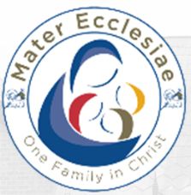
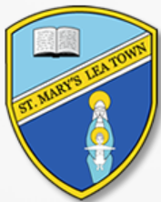
St Mary’s Catholic Primary School Governor roles and responsibilities.

Role | Governor
Safeguarding & Backup Safeguarding | Jackie Fitzpatrick and Barbara Gardner
Maths | Jackie Fitzpatrick
English and Phonics | Sarah Bolton-Rigby
RE and HRSE (including Laudato Si) | Barbara Gardner
Science and STEM (Science, Technology, Engineering and Maths) | Barbara Gardner
DT and Art | Angela Pye
Modern Foreign Language | Victoria Houlding
Inclusion (Sen and PP) | Jackie Fitzpatrick
Early Years and Foundation Stage | Sarah Bolton-Rigby
Mental Wellbeing | Clare Kennedy
PE | Victoria Houlding
Geography and History | Victoria Houlding
Music | Angela Pye
Computing | Clare Kennedy
Health and Safety | Sarah Bolton-Rigby
Educational Visits | Angela Pye
Training link governor | Sarah Bolton-Rigby
School council (including pupil voice) | Angela Pye
Website compliance | Sarah Bolton-Rigby

